**A MINI PROJECT REPORT ON AUTOMATION SANITIZER**

***A Mini Project submitted to Jawaharlal Nehru TechnologicalUniversity, Kakinada***

**BACHELOR OF TECHNOLOGY**

**IN**

**COMPUTER SCIENCE & ENGINEERING**



**Submitted By**

**K. BHAVANA (20KT1A4725)**

**S. GOWRI PAVANI (20KT1A4752)**

**V.PRATYUSHA (20KT1A4761)**

Under the guidance of

**Mr. V.S.R.K PRASAD, M.Tech**

***Assistant Professor, CSE Department***

**Department of Computer Science & Engineering**

**POTTI SRIRAMULU CHALAVADI MALLIKARJUNA RAO COLLEGE OF ENGINEERING & TECHNOLOGY**

***(Approved by AICTE, Affiliated to JNTU Kakinada)***

**KOTHAPETA, VIJAYAWADA-520001, A.P.**

**2020-2024**

**POTTI SRIRAMULU CHALAVADI MALLIKARJUNA RAO**

**COLLEGE OF ENGINEERING & TECHNOLOGY**

**Kothapeta, Vijayawada,Krishna Dt. A.P.India.**

**DEPARTMENT OF COMPUTER SCIENCE & ENGINEERING**

**INTERNET OF THINGS AND CYBER SECURITY INCLUDING BLOCKCHAIN TECHNOLOGY**



**CERTIFICATE**

This is to certify that the mini project work entitled “**automation sanitizer”** is a bonafide work carried out by **“Ms.K.BHAVANA (Roll No:20KT1A4725), Ms.S.GOWRI PAVANI (Roll No:20KT1A4752), Ms.D.V.PRATYUSHA (Roll No:20KT1A4761)”Bachelor of Technology in Computer Science & Engineering of Jawaharlal Nehru Technological University-Kakinada** during the year 2020-2024.

**Project Guide Head of the Department**

**ABSTRACT**

Viruses such as COVID-19 are transferrable through touch and contact. There

are WHO guidelines to clean or sanitize hands regularly to reduce the risk of infection.

Dispensing of sanitizer from bottle and storage would require manual intervention. In this

paper we propose a novel design of touch-less sanitizer machine to reduce the risk due to

contact. The system can sense the proximity with the help of ultrasonic sensor and sends

signal to microcontroller. The controller processes the sensor data & actuates the pump

and solenoid valve. The sanitizer liquid dispenses through mist nozzle.

Abstract:

Viruses such as COVID-19 are transferrable through touch and contact. There

are WHO guidelines to clean or sanitize hands regularly to reduce the risk of infection.

Dispensing of sanitizer from bottle and storage would require manual intervention. In this

paper we propose a novel design of touch-less sanitizer machine to reduce the risk due to

contact. The system can sense the proximity with the help of ultrasonic sensor and sends

signal to microcontroller. The controller processes the sensor data & actuates the pump

and solenoid valve. The sanitizer liquid dispenses through mist nozzle.

Viruses such as COVID-19 are transferrable through touch and contact. There

are WHO guidelines to clean or sanitize hands regularly to reduce the risk of infection.

Dispensing of sanitizer from bottle and storage would require manual intervention. In this

paper we propose a novel design of touch-less sanitizer machine to reduce the risk due to

contact. The system can sense the proximity with the help of ultrasonic sensor and sends

signal to microcontroller. The controller processes the sensor data & actuates the pump

and solenoid valve. The sanitizer liquid dispenses through mist nozzle

Viruses such as COVID-19 are transferrable through touch and contact. There

are WHO guidelines to clean or sanitize hands regularly to reduce the risk of infection.

Dispensing of sanitizer from bottle and storage would require manual intervention. In this

paper we propose a novel design of touch-less sanitizer machine to reduce the risk due to

contact. The system can sense the proximity with the help of ultrasonic sensor and sends

signal to microcontroller. The controller processes the sensor data & actuates the pump

and solenoid valve. The sanitizer liquid dispenses through mist nozzle

Viruses such as COVID-19 are transferrable through touch and contact. There

are WHO guidelines to clean or sanitize hands regularly to reduce the risk of infection.

Dispensing of sanitizer from bottle and storage would require manual intervention. In this

paper we propose a novel design of touch-less sanitizer machine to reduce the risk due to

contact. The system can sense the proximity with the help of ultrasonic sensor and sends

signal to microcontroller. The controller processes the sensor data & actuates the pump

and solenoid valve. The sanitizer liquid dispenses through mist nozzle

Viruses such as COVID-19 are transferrable through touch and contact. There

are WHO guidelines to clean or sanitize hands regularly to reduce the risk of infection.

Dispensing of sanitizer from bottle and storage would require manual intervention. In this

paper we propose a novel design of touch-less sanitizer machine to reduce the risk due to

contact. The system can sense the proximity with the help of ultrasonic sensor and sends

signal to microcontroller. The controller processes the sensor data & actuates the pump

and solenoid valve. The sanitizer liquid dispenses through mist nozzle

Viruses such as COVID-19 are transferrable through touch and contact. There

are WHO guidelines to clean or sanitize hands regularly to reduce the risk of infection.

Dispensing of sanitizer from bottle and storage would require manual intervention. In this

paper we propose a novel design of touch-less sanitizer machine to reduce the risk due to

contact. The system can sense the proximity with the help of ultrasonic sensor and sends

signal to microcontroller. The controller processes the sensor data & actuates the pump

and solenoid valve. The sanitizer liquid dispenses through mist nozzle

Viruses such as COVID-19 are transferrable through touch and contact. There

are WHO guidelines to clean or sanitize hands regularly to reduce the risk of infection.

Dispensing of sanitizer from bottle and storage would require manual intervention. In this

paper we propose a novel design of touch-less sanitizer machine to reduce the risk due to

contact. The system can sense the proximity with the help of ultrasonic sensor and sends

signal to microcontroller. The controller processes the sensor data & actuates the pump

and solenoid valve. The sanitizer liquid dispenses through mist nozzle

Viruses such as COVID-19 are transferrable through touch and contact. There are WHO guidelines to clean or sanitize hands regularly to reduce the risk of infection. Dispensing of sanitizer from bottle and storage would require manual intervention. In this project we propose a design of touch-less sanitizer machine to reduce the risk due to contact. The system can sense the proximity with the help of Ir sensor and sends signal to microcontroller. The controller processes the sensor data & actuates the pump and solenoid valve. The sanitizer liquid dispenses through mist nozzle.

**INTRODUCTION**

Hygiene is an important aspect to remain healthy. There are various aspects of hygiene. A clean hand is one of them. Hands generally are touched at various surfaces and can be exposed to direct contamination. Cleaning hands at regular interval is recommended by various health organizations including WHO. Hand hygiene is now regarded as one of the most important element of infection control activities. In the wake of the growing burden of health care associated infections (HCAIs), the increasing severity of illness and complexity of treatment, superimposed by multi-drug resistant (MDR) pathogen infections, health care practitioners (HCPs) are reversing back to the basics of infection preventions by simple measures like hand hygiene. This is because enough scientific evidence supports the observation that if properly implemented, hand hygiene alone can significantly reduce the risk of cross-transmission of infection in healthcare facilities (HCFs)1–5. Evidence suggests that hand sanitization significantly reduces the transmission of healthcare-associated pathogens and the incidence of HCAI (healthcare associated infections).[6]. According to the Center for Disease Control and Prevention (CDC), hand hygiene encompasses the cleansing of your hands using soap and water, antiseptic hand washes, alcohol-based hand sanitizers (ABHS), or surgical hand antiseptics. These days, alcohol-based hand sanitizers are increasingly being used instead of soap and water for hand hygiene in healthcare settings. Poor or inadequate hand washing and/or hand hygiene is known to be problematic in hospital settings, and is a major source of infections contracted while patients are admitted to a hospital. While hand washing and hygiene policies and training are important and can be effective in reducing the spread of infections, the problem of infections due to unsatisfactory hygiene of staff, medical professionals, and even patients continues to be problematic. It is known to place hand washing stations and hand sanitizer dispensers throughout medical facilities including in examination rooms, hallways, lobbies, and even patient rooms. However, such systems are purely mechanical and are incapable of providing an automated means of establishing accountability of good hygienic practices [7]. During the last quarter of 2019, a collection of unusual pneumonia cases went from a local concern to a global pandemic in a matter of 70 days. The infamous Severe Acute ISSN No: 0932-4747 Page No:228 Zeichen Journal Volume 6, Issue 8, 2020 Respiratory Syndrome Coronavirus 2 (SARS-CoV-2) is the virus that was first reported in Wuhan, China on December 31, 2019, and was announced as a pandemic by the World Health Organization on March 11, 2020.

**about the project:**

The need of touch-less automatic dispenser is identified after observing that it is the point of contact for contamination. in this project we present a design of automatic hand sanitizer dispenser. the circuit includes a ir sensor . the sensor senses the proximity of hands under the machine.the sensor send signal to the microcontroller and the controller takes decision to actuate the pump and valve simultaneously to dispense the liquid sanitizer through a mist nozzle.

**problem statement:**

We have designed a sanitizer dispensing machine in a plastic cabinet . The system consists of Ir sensor based on principles. The sensor used in the system is to sense the hands are under the machine or not. The cabinet design was originally fabricated for water RO system and has been modified for the purpose of sanitizer dispensing action. The sanitizer storage section is on the front side upper region. Filters have been removed and the water dispensing tap has also been removed. Mist nozzle has been added at the bottom side of the cabinet. The pump is used to suck the sanitizer and pump it with a pressure to the nozzle. The solenoid valve has also been used to control the opening of nozzle and to facilitate to control the dispensing of liquid sanitizer. Pipes and attachments helped to make it easy to fabricate.

**COMPONENTS:**

**Arduino uno**

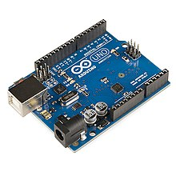

Arduino Uno is a microcontroller board based on the ATmega328. It has 20 digital

input/output pins (of which 6 can be used as PWM outputs and 6 can be used as analog

inputs), a 16 MHz resonator, a USB connection, a

power jack, an in-circuit system programming (ICSP)

header, and a reset button. It contains everything

needed to support the microcontroller; simply

connect it to a computer with a USB cable or power

it with a AC-to-DC adapter or battery to get started.

For this project build, we needed a Microcontroller

to control the Input and Output, sense the Trigger

from the Sensor and Process the

Output in form of Servo in our Prototype. And also, easy to adjust the parameters, fine-tune

outputs

**Ir –Sensor –Module**

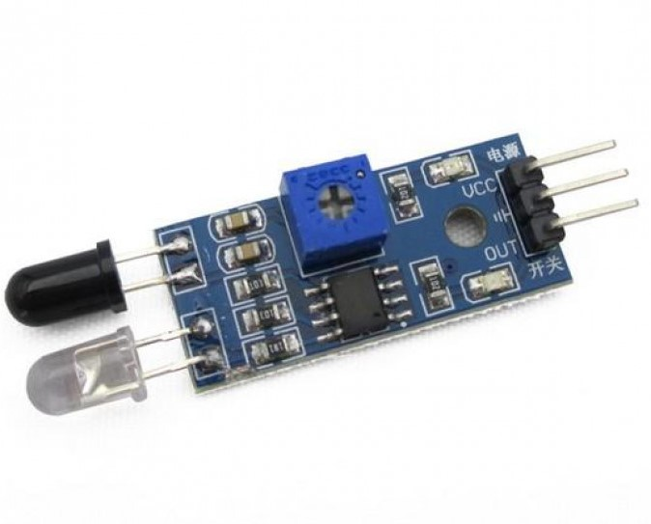

**Servomotor:**

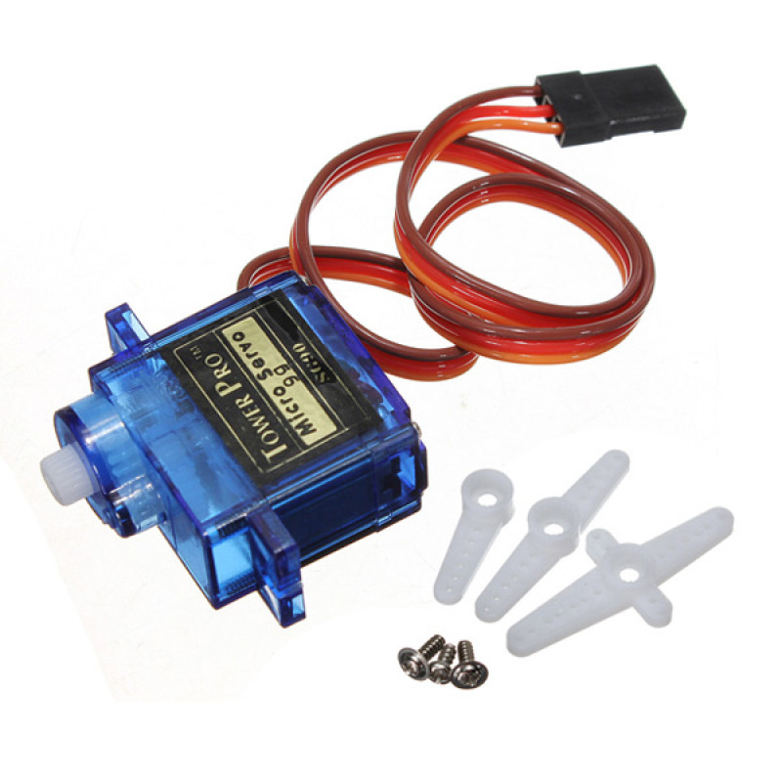

**Jumper wires:**

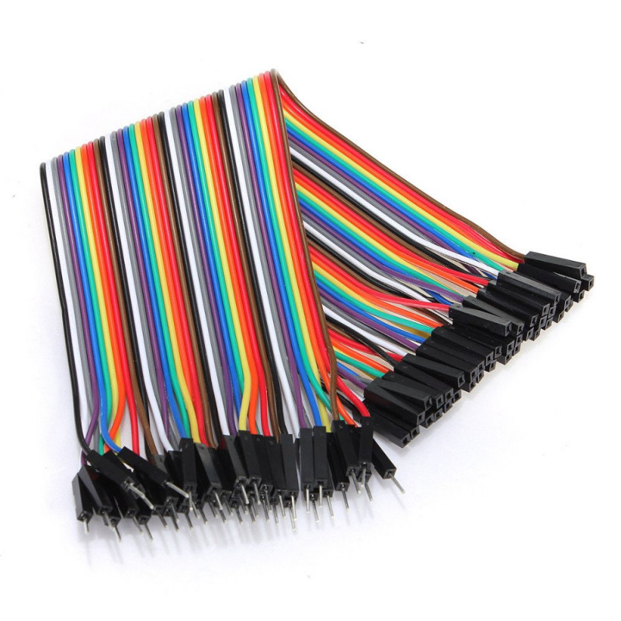

**Sanitizer bottle:**

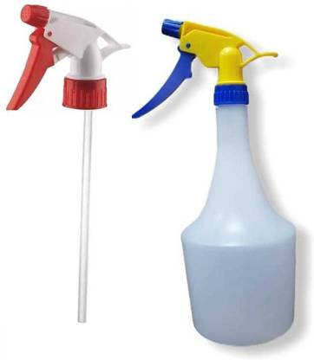

**CIRCUIT DIAGRAM:**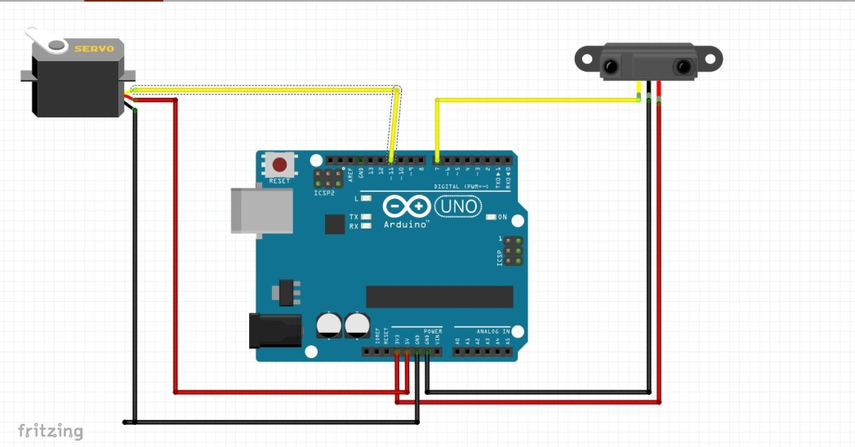

**DESIGN:**

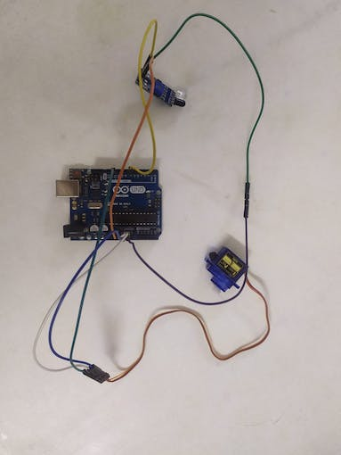

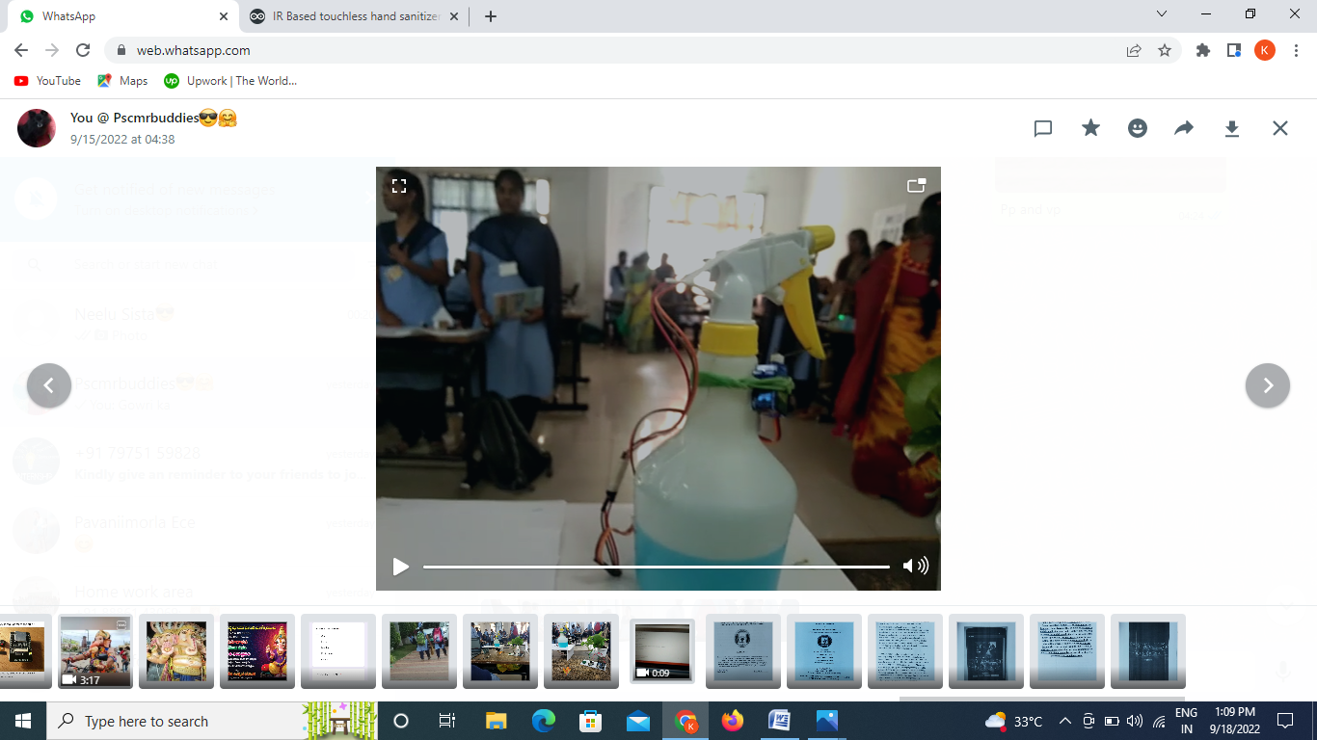

**CODE:** #include <Servo.h>

// Declare the Servo pin

int servoPin = 3;

int ir=8;

// Create a servo object

Servo Servo1;

void setup()

{

pinMode(ir,INPUT);

// We need to attach the servo to the used pin number

Servo1.attach(servoPin);

Serial.begin(9600);

}

void loop()

{

int irvalue=digitalRead(ir);

Serial.println(irvalue);

if(irvalue==0)

{

int i=0;

while(i<3)

// Make servo go to 0 degrees

{

Servo1.write(0);

delay(200);

// Make servo go to 90 degrees

Servo1.write(150);

delay(200);

// Make servo go to 180 degrees

Servo1.write(0);

delay(200);

i++;

}

}

delay(100);

}

**RESULT:**

